TECHNICAL GUIDE
Anaplan- Forecasting Model Integration
SOP of How data moves between Anaplan and our forecasting model
Prepared by Reetesh Verma , Data Scientist, EXL
August 2026

Table of Contents
Table of Contents
1. Description
Basic Flow
2. Logging In
3. Data Lookup
4. Pulling Data from Anaplan
Step 1 Start the export
Step 2 Wait for it to finish
Step 3 Download the file
5. Running Our Forecast model
6. Pushing the Forecast Back Into Anaplan
Step 1 Tell Anaplan a file is coming
Step 2 Upload the file, piece by piece
Step 3 Mark the upload finished
Step 4 Run the import
8. The Code
9. Notes
Appendix
References

1. Description
This document explains, in plain terms, how our forecasting model connects to a real Anaplan tenant using the Anaplan Integration API v2. It walks through the same four steps every time: log in, pull data out of Anaplan, run our forecast, and push the results back in.
Everything here talks to a live Anaplan account at https://api.anaplan.com/2/0. There is no test/mock mode the calls shown are the real calls a working integration makes.
Basic Flow
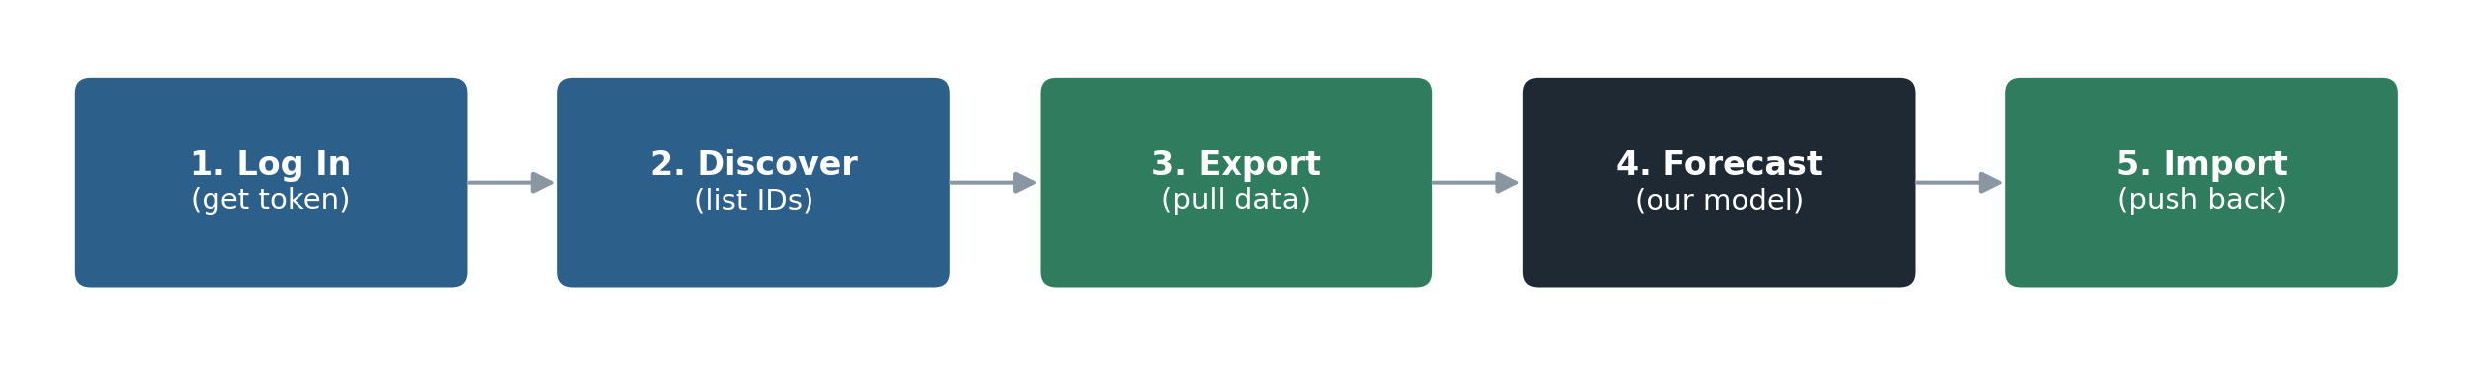
2. Logging In
Firstly we need a login token from Anaplan. This token is separate from the main API it comes from a different address (auth.anaplan.com) and it stays valid for 35 minutes. We reuse the same token for that whole window rather than logging in again for every call.
Log in with the Anaplan account’s username and password:
curl
curl -X POST https://auth.anaplan.com/token/authenticate \
-H "Authorization: Basic base64(email:password)"

Anaplan sends back a token:
response
{
"tokenInfo": {
"tokenValue": "eyJhbGciOiJSUzI1NiIs...",
"expiresAt": 1735000000000
}
}

Every call after that includes this token in its header:
header on every call
Authorization: AnaplanAuthToken {tokenValue}

For day-to-day testing, a username and password is fine. If this ever runs on a schedule with no one watching it, it’s worth switching to certificate-based login instead it doesn’t expire every 90 days the way a password does. That’s a later decision, not something needed for the POC.
Because the token only lasts 35 minutes, the code checks the time before every call and quietly gets a fresh token if the old one is about to expire so a long-running job never gets stuck on an expired login.

3. Data Lookup
Before pulling any data, we ask Anaplan what exists: which workspaces, models, views, and so on we have access to. These are all simple "give me the list" calls:
We want to see... | We call...
Workspaces | GET /workspaces
Models | GET /workspaces/{workspaceId}/models
Modules / Views / Lists / Files | GET /workspaces/{ws}/models/{model}/{resource}
Imports / Exports / Processes / Actions | GET /workspaces/{ws}/models/{model}/{resource}
Table 1: Every discovery call has the same shape.
4. Pulling Data from Anaplan
Anaplan treats an export like a small job: we start it, wait for it to finish, then download the result. Three steps.
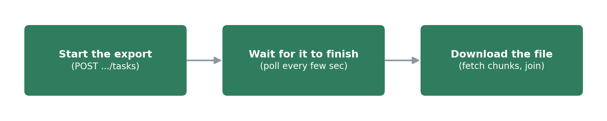
Step 1 Start the export
curl
curl -X POST \
https://api.anaplan.com/2/0/workspaces/{ws}/models/{model}/exports/{exportId}/tasks \
-H "Authorization: AnaplanAuthToken {token}" \
-H "Content-Type: application/json" \
-d '{"localeName": "en_US"}'

Anaplan replies with a task ID we’ll use to check progress.
Step 2 Wait for it to finish
We check the task every couple of seconds until it says COMPLETE:
endpoint + response
GET /workspaces/{ws}/models/{model}/exports/{exportId}/tasks/{taskId}

{ "task": { "taskState": "COMPLETE", "result": { "successful": true } } }

Step 3 Download the file
The exported data comes back as a file, split into one or more pieces (chunks) if it’s large. We fetch each piece and join them together:
anaplan_client.py
def download_file(self, ws, model, file_id) -> bytes:
chunks = self._request(
"GET", f"/workspaces/{ws}/models/{model}/files/{file_id}/chunks"
).json()["chunks"]
data = b""
for chunk in chunks:
resp = self._request(
"GET",
f"/workspaces/{ws}/models/{model}/files/{file_id}/chunks/{chunk['id']}",
)
data += resp.content
return data

In the code, all three steps happen with one call: export_view_to_dataframe(...) it returns the exported data as a table (a pandas DataFrame) ready for forecasting.
5. Running Our Forecast model
This step doesn’t talk to Anaplan at all it’s our own model, running on the table we just exported. The only thing that matters here is the shape of the data going in and coming out, so the model can be swapped freely without touching the Anaplan side:
 | Columns
Data in (from Anaplan) | Region, Product, Month, Actual Demand
Data out (back to Anaplan) | Region, Product, Month, Forecast Demand
Table 2: Same dimensions on both sides only the value column and time period change.
forecast_engine.py holds this logic. Today it’s a simple trend line so the pipeline can be tested end-to-end; swapping in the real production model just means replacing that one function.
6. Pushing the Forecast Back Into Anaplan
This is the export process in reverse, with one extra step: the file has to be uploaded before Anaplan can import it.
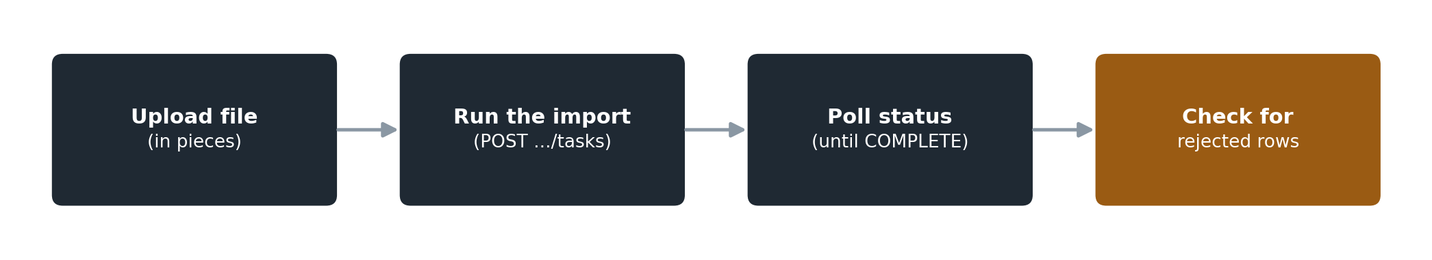
Step 1 Tell Anaplan a file is coming
endpoint + body
POST /workspaces/{ws}/models/{model}/files/{fileId}
Content-Type: application/json

{ "chunkCount": -1 }

Step 2 Upload the file, piece by piece
Same chunking idea as the download, in reverse. Each piece is 1–50 MB:
anaplan_client.py
for chunk_id, chunk in enumerate(chunks_of(data)):
self._request(
"PUT",
f"/workspaces/{ws}/models/{model}/files/{file_id}/chunks/{chunk_id}",
data=chunk,
headers={"Content-Type": "application/octet-stream"},
)

Step 3 Mark the upload finished
endpoint + body
POST /workspaces/{ws}/models/{model}/files/{fileId}/complete

{ "id": fileId, "name": "forecast.csv", "chunkCount": 3 }

Step 4 Run the import
curl
curl -X POST \
https://api.anaplan.com/2/0/workspaces/{ws}/models/{model}/imports/{importId}/tasks \
-H "Authorization: AnaplanAuthToken {token}" \
-H "Content-Type: application/json" \
-d '{"localeName": "en_US"}'

We poll this the same way as the export. One thing worth knowing: an import can say COMPLETE even if a few individual rows were rejected. When that happens, Anaplan makes a small error file available listing which rows failed and why our code checks for this and logs it instead of assuming everything landed.
In the code, upload and import happen together with two calls: upload_dataframe(...) then run_import(...).
7. Code part
Three files, kept deliberately small:
File | What it does
anaplan_client.py | Talks to Anaplan: login, discovery, export, import, error handling.
forecast_engine.py | Our forecast logic. This is the only file that changes when the real model is plugged in.
run_integration.py | Runs the whole thing start to finish, one command.
Table 4: File structure.
Running it looks like this:
terminal
python run_integration.py \
--email you@company.com --password *** \
--workspace-id <ws> --model-id <model> \
--export-id <exportId> --export-file-id <fileId> \
--import-id <importId> --import-file-id <fileId>

In a real deployment, the email and password would come from a secrets manager or environment variables, not typed on the command line the flags above are for local testing only.
8. Notes
- Make sure the Anaplan account we’re using can read the source view and write to the target module.
- Get the real workspace ID, model ID, export ID, and import ID from Anaplan these are fixed IDs, not something we guess.
- Test with a small export first to confirm the column names match what forecast_engine.py expects.
- Keep credentials out of the code environment variables or a secrets manager, never hardcoded.
Decide how this gets triggered going forward on a schedule, on demand, or after something else finishes once the first real run is validated.

Appendix
What it does | Call
Log in | POST auth.anaplan.com/token/authenticate
Refresh login | POST auth.anaplan.com/token/refresh
List workspaces | GET /workspaces
List models | GET /workspaces/{ws}/models
List modules/views/lists/files/imports/exports/processes/actions | GET /workspaces/{ws}/models/{model}/{resource}
Start export | POST /workspaces/{ws}/models/{model}/exports/{exportId}/tasks
Check task progress | GET /workspaces/{ws}/models/{model}/{resource}/{id}/tasks/{taskId}
List file pieces (chunks) | GET /workspaces/{ws}/models/{model}/files/{fileId}/chunks
Download a piece | GET /workspaces/{ws}/models/{model}/files/{fileId}/chunks/{chunkId}
Announce an upload | POST /workspaces/{ws}/models/{model}/files/{fileId}
Upload a piece | PUT /workspaces/{ws}/models/{model}/files/{fileId}/chunks/{chunkId}
Finish an upload | POST /workspaces/{ws}/models/{model}/files/{fileId}/complete
Start import | POST /workspaces/{ws}/models/{model}/imports/{importId}/tasks
Get rejected-row details | GET /workspaces/{ws}/models/{model}/imports/{importId}/tasks/{taskId}/dump
Every call anaplan_client.py makes, in one place

References

- https://help.anaplan.com/integration-api-v20-3107aa54-d12b-4c48-9550-3561c84adbb2
- https://anaplan.docs.apiary.io/#ListUserWorkspaces
- https://anaplan.docs.apiary.io/#/reference/workspaces

